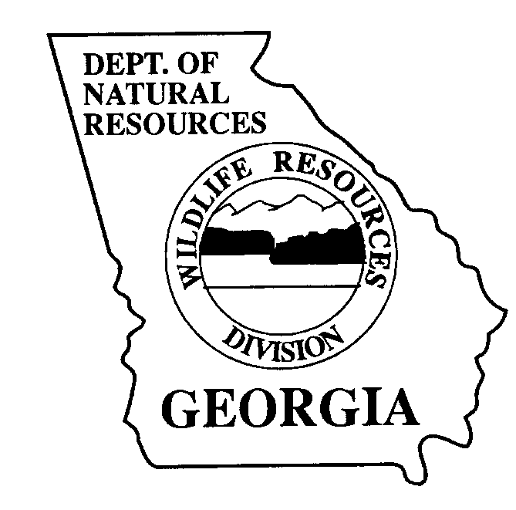
The Georgia Department of Natural Resources

Wildlife Resources Division

TROUT FACT SHEET

LIFE HISTORY
Anglers are fortunate to be able fish for three species of trout in Georgia.
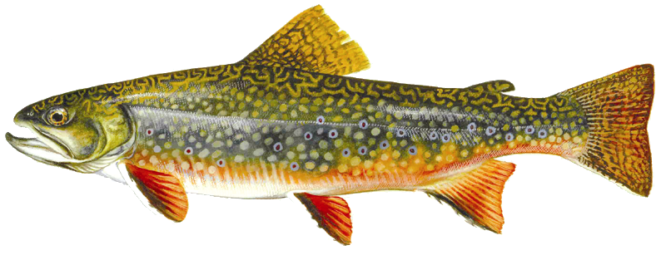
The Brook trout, Salvelinus fontinalis, is the only trout native to Georgia. It has light, “worm-like” markings on a dark upper body and vivid white leading edges on the lower fins.

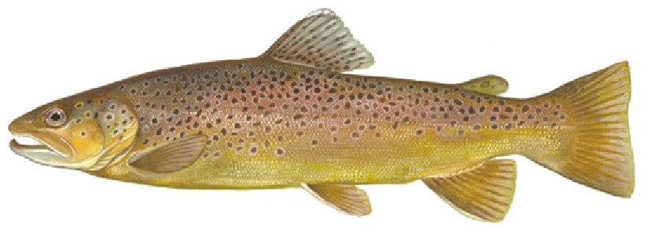
The Brown trout, Salmo trutta, is not native to Georgia or North America. Their native range includes the British Isles and most of Europe. It is olive green to brown on top shading to a creamy, golden-yellow on the sides, black and red-orange spots surrounded by a light halo on the sides, and a square caudal fin with few spots.

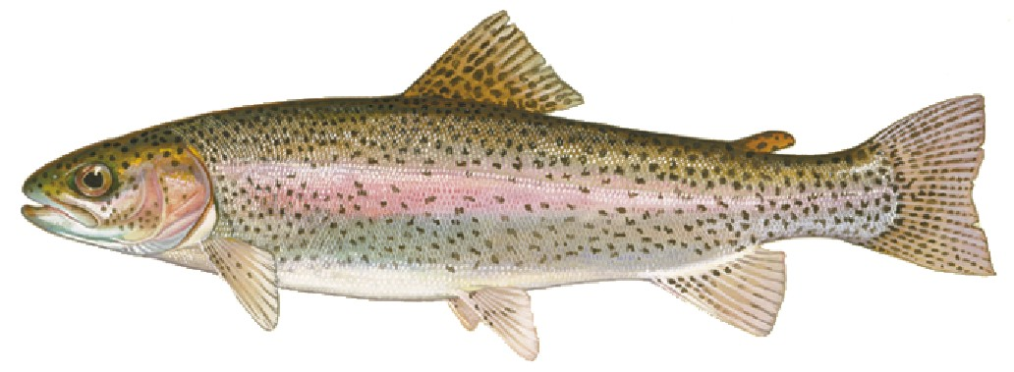

The Rainbow trout, Oncorhynchus mykiss, is also not native to Georgia and originates from the Pacific coast of the United States. It has a prominent pink-red horizontal stripe on each side of a silvery body and small black dots throughout the body that extend into the caudal fin.

Rainbow and Brown trout were both introduced into Georgia streams in the 1880s and have been stocked for over a century. Natural reproduction of brook, brown, and rainbow trout occur in many streams. Because the brown and rainbow trout have naturally reproduced for many years, the Georgia Department of Natural Resources classifies them as naturalized species. Trout belong to the Salmon family. They require continuously flowing, well oxygenated (above 6 milligrams per liter), and cold water (water temperatures less than 72ºF) to survive. Georgia has approximately 5,400 miles of designated trout water located in the north Georgia mountains.

Trout require streams with gravel bottoms for spawning. When the water temperature approaches 50ºF, a female trout searches for suitable habitat to lay her eggs. The female makes a shallow depression in the gravel, called a redd, into which the eggs are deposited. Young females deposit 200 to 500 eggs, but larger fish may produce 2,500 eggs or more. After the female deposits her eggs, one or more males deposit milt (sperm) over the eggs to fertilize them. After the eggs are fertilized, the female gently sweeps gravel over the eggs with her tail to protect them while they incubate. The eggs will hatch in 30 to 45 days, depending on the water temperature, and may not emerge from the gravel for several more weeks.

After hatching from the egg, trout fry survive on the nourishment contained in a tiny yolk sac until they are able to catch their own food. Their first solid food is usually zooplankton, but as they grown, they will catch and eat a variety of organisms including aquatic insects, like mayflies, caddsflies, and stoneflies; fish, crayfish, and even terrestrial insects, like ants and spiders that fall into the water. By the end of their first year of life, a wild trout may reach a length of 4-inches. In their second year, they may be 6-inches long, and by their third year, trout may be 8 to 9-inches long. From a single nest of eggs, less than 10% will likely survive to maturity, and seldom do wild trout live beyond three years. Brown trout and Brook trout spawn in October and November, whereas Rainbow trout spawn in the spring. Approximately 2,800 of Georgia’s 5,400 miles of trout streams support wild trout populations where trout reproduce. About 142 miles of streams support the native brook trout.

The current state records for trout in Georgia reflect the ability of some individuals to live well beyond age 3 under ideal habitat conditions and with an abundance of food. The state record Brook trout weighs 5 lb, 10 ounces and was caught in Waters Creek on March 29, 1986. The state record Rainbow trout weighs 17 lb, 8 ounces and was caught in the Soque River on May 7, 2004. The state record Brown trout was caught in the Chattahoochee River on November 12, 2001 and weighed 18 lb, 6 oz.

THREATS TO TROUT IN GEORGIA
Because trout require clean, cold water to survive, they are very sensitive to subtle environmental changes. The rapid expansion of urban development throughout the mountains contributes to habitat degradation and loss. Erosion and sedimentation are the greatest threats to successful trout reproduction in Georgia. When sediments settle on the bottom, they prevent oxygen rich water from flowing over the eggs. The eggs will suffocate and die from lack of oxygen. Poor land use practices, such as removing shrubs and trees that grown along the streamside and provide important shade, cause the water to become warmer and allow silt and sediments to wash into the stream. Stormwater run-off from paved parking lots also allows heated water to flow into trout streams. Ensuring that everyone takes measures to keep soil in its proper place and that a 50-feet wide vegetated buffer zone remains along each bank of trout streams will adequately protect Georgia’s trout resources for future generations to enjoy.

FISHERIES MANAGEMENT IN GEORGIA
The Fisheries Section of the Department of Natural Resources is the state government agency that is responsible for managing Georgia’s freshwater fishery resources. Trout management efforts in Georgia include annual population surveys, setting protective size and creel limits, protecting spawning habitat and water quality, and producing catchable-sized (9-11 inches) rainbow and brown trout at three trout hatcheries.

Because the naturally low fertility in our mountain streams can only support a low abundance of fish, trout are stocked in 160 streams across north Georgia to provide recreational fishing opportunities for anglers. The Department of Natural Resources and U.S. Fish and Wildlife Service stock over one million catchable-sized (9-11 inches) trout annually to maintain quality trout fishing in Georgia. The traditional stocking season runs from March through Labor Day. Approximately 160,000 anglers over age 16 years fish for trout, and their purchases of fishing licenses, trout fishing tackle and bait has an economic impact of $172 million annually.

TROUT FISHING TIPS FOR BEGINNERS
Streams that are stocked regularly with trout are the best places for beginning trout anglers to learn to trout fish, and the spring and fall months are the best times to catch fish. A map of the Trout Streams in Georgia is available at the WRD website (www.gofishgeorgia.com), and it highlights areas where anglers may fish stocked trout streams on public lands.

The gear and tackle requirements for basic trout fishing are relatively simple to use and inexpensive to purchase. A 5 to 6-foot long ultralight fishing rod with a spinning or spincast reel is ideal tackle for the beginning trout angler. Light line in 4 to 6 pound test is recommended. Tie a number 10 hook to the end of the line and add one or two small weights (size BB split shot) to the line about 12-inches above the hook. Common trout baits are niblet corn, red wiggler worms, crickets, and salmon eggs. Put enough bait on your hook to cover it.

Trout are usually found near the bottom in deep pools and slower pockets and eddies behind large rocks. Standing downstream of the place where trout might be, cast the bait several feet upstream of the target and allow the bait to drift downstream into the target area. Slowly reel in the slack line as the bait drifts downstream. After several casts without a strike, move upstream to the next likely spot. When a trout takes the bait, you will feel several slight tugs on the line. If you feel a tugging on the line, pull the rod tip up quickly to set the hook.

It is important to know the rules and regulations about trout fishing. Trout anglers age 16 and up must have in their possession a fishing license and trout license. Anglers may only fish with one rod during daylight hours and each angler must have their own stringer. On seasonal trout streams, the creel limit (how many you may keep) for trout is 8 fish, and there is no size limit. For more information about trout fishing rules, regulations, and license requirements or about the Fisheries Section in Georgia, visit the website at www.gofishgeorgia.com.

